**PROJECT REPORT**

ON

LEVERAGING ELASTIC BEANSTALK AND HOST FULL STACK APPLICATION

**INDEX**

|  |  |  |
| --- | --- | --- |
| NO | TITLE | PG NO. |
| 1. | Abstract | 3 |
| 2. | Objective | 4 |
| 3. | Introduction | 6 |
| 4. | Methodology | 8 |
| 5. | Code | 11 |
| 6. | Output | 14 |
| 7. | Conclusion | 15 |

**Abstract**

In today's dynamic digital landscape, deploying and managing full-stack applications efficiently is paramount for developers seeking to deliver robust solutions while minimizing infrastructure management overhead. This project explores the utilization of Amazon Web Services (AWS) Elastic Beanstalk, a Platform as a Service (PaaS) offering, to streamline the deployment and hosting process of full-stack applications. Elastic Beanstalk abstracts away the complexities of infrastructure provisioning and configuration, empowering developers to focus solely on crafting their application logic and user experience.

The project delves into the intricacies of setting up Elastic Beanstalk environments, encompassing the deployment of both backend and frontend components of the application stack. This includes configuring scalable compute resources, such as EC2 instances or containers, to host backend services like databases, APIs, and application servers. Additionally, it elucidates the seamless integration of frontend components, such as static web assets or client-side frameworks, ensuring a cohesive end-to-end deployment solution.

Furthermore, the project provides a comprehensive walkthrough of the deployment process, highlighting the steps required to package and deploy applications to Elastic Beanstalk environments. Leveraging the elasticity and auto-scaling capabilities inherent in Elastic Beanstalk, developers can confidently scale their applications in response to fluctuating traffic demands, ensuring optimal performance and cost efficiency.

Beyond deployment, the project explores the monitoring and management features offered by Elastic Beanstalk, enabling developers to gain insights into application health, performance metrics, and resource utilization. Through built-in monitoring dashboards and integration with AWS CloudWatch, developers can proactively identify and address any issues affecting application performance, ensuring a seamless user experience.

Overall, this project demonstrates the efficacy of leveraging Elastic Beanstalk as a robust deployment platform for hosting full-stack applications. By abstracting away infrastructure complexities and providing a suite of management tools, Elastic Beanstalk empowers developers to accelerate the deployment lifecycle, iterate rapidly, and deliver reliable, scalable applications to end-users with confidence.

**Objective**

The objective of this project is to explore and demonstrate the utilization of Amazon Web Services (AWS) Elastic Beanstalk as a deployment platform for hosting full-stack applications. Specifically, the project aims to:

1. Provide developers with a comprehensive understanding of the setup and configuration of Elastic Beanstalk environments, encompassing both backend and frontend components of the application stack.

2. Showcase the deployment process of full-stack applications to Elastic Beanstalk, emphasizing best practices for packaging, deployment, and version management.

3. Highlight the scalability and auto-scaling capabilities of Elastic Beanstalk, enabling developers to efficiently manage resources and adapt to changing traffic demands.

4. Investigate the monitoring and management features offered by Elastic Beanstalk, empowering developers to proactively monitor application health, performance metrics, and resource utilization.

5. Illustrate the benefits of leveraging Elastic Beanstalk, including reduced infrastructure management overhead, accelerated deployment lifecycles, and enhanced scalability and reliability of full-stack applications.

6. Equip developers with the knowledge and skills necessary to leverage Elastic Beanstalk effectively, thereby enabling them to deploy robust, scalable full-stack applications with confidence on the AWS cloud platform.

7. Explore advanced configuration options and customization capabilities of Elastic Beanstalk, including environment variables, resource allocation, and deployment strategies, to optimize application performance and resource utilization.

8. Address common challenges and best practices for integrating various components of full-stack applications within Elastic Beanstalk environments, such as database connections, load balancers, caching layers, and external services.

9. Investigate strategies for continuous integration and continuous deployment (CI/CD) pipelines with Elastic Beanstalk, enabling developers to automate the deployment process and streamline development workflows.

10. Evaluate cost optimization techniques and considerations when using Elastic Beanstalk, including instance types, scaling policies, and utilization of AWS cost management tools, to ensure cost-effective deployment and operation of full-stack applications.

11. Provide real-world use cases and examples of organizations or projects successfully leveraging Elastic Beanstalk for hosting full-stack applications, illustrating the practical applications and benefits of the platform.

12. Offer guidance on security best practices and compliance considerations when deploying full-stack applications on Elastic Beanstalk, including network security, data encryption, access control, and compliance with industry standards and regulations.

By addressing these additional objectives, the project aims to equip developers with comprehensive knowledge and practical insights into leveraging Elastic Beanstalk as a powerful platform for deploying, managing, and scaling full-stack applications effectively on the AWS cloud infrastructure.

**Introduction**

In the ever-evolving landscape of software development, the deployment and management of full-stack applications pose significant challenges for developers. The complexities of provisioning infrastructure, configuring services, and ensuring scalability often divert valuable time and resources away from actual application development. In response to these challenges, cloud computing platforms have emerged as indispensable tools, offering scalable and reliable solutions to streamline the deployment lifecycle. Among these platforms, Amazon Web Services (AWS) stands out as a pioneer, providing a vast array of services designed to empower developers and organizations to build, deploy, and scale applications with unprecedented efficiency and flexibility.

One such service offered by AWS is Elastic Beanstalk, a Platform as a Service (PaaS) offering that simplifies the deployment and management of applications by abstracting away the underlying infrastructure complexities. Elastic Beanstalk enables developers to focus solely on writing code and crafting compelling user experiences, while it takes care of the heavy lifting associated with deployment, scaling, and monitoring. By automating the provisioning of resources, configuring load balancers, and managing auto-scaling policies, Elastic Beanstalk empowers developers to deploy full-stack applications seamlessly, without the need for deep expertise in infrastructure management.

This project aims to delve deep into the realm of deploying and hosting full-stack applications using AWS Elastic Beanstalk as the underlying deployment platform. Throughout this exploration, we will uncover the intricacies of setting up Elastic Beanstalk environments, encompassing both backend and frontend components of the application stack. We will explore advanced configuration options, customization capabilities, and best practices for integrating various components such as databases, APIs, and frontend frameworks within Elastic Beanstalk environments.

Furthermore, this project will provide a comprehensive walkthrough of the deployment process, emphasizing best practices for packaging, version management, and continuous integration and deployment (CI/CD) pipelines. Leveraging the scalability and auto-scaling capabilities inherent in Elastic Beanstalk, we will demonstrate how developers can efficiently manage resources and adapt to changing traffic demands, ensuring optimal performance and cost efficiency.

In addition to deployment, this project will also investigate the monitoring and management features offered by Elastic Beanstalk, enabling developers to gain insights into application health, performance metrics, and resource utilization. By proactively monitoring and managing their applications, developers can identify and address potential issues before they impact end-users, ensuring a seamless and reliable user experience.

Moreover, this project will evaluate cost optimization techniques and considerations when using Elastic Beanstalk, helping developers to strike the right balance between performance, scalability, and cost-effectiveness. By understanding and implementing cost optimization strategies, developers can deploy and operate full-stack applications on Elastic Beanstalk with confidence, knowing they are maximizing value and minimizing unnecessary expenditure.

Through real-world use cases, examples, and practical insights, this project aims to equip developers with the knowledge and skills necessary to leverage Elastic Beanstalk effectively for deploying, managing, and scaling full-stack applications on the AWS cloud infrastructure. By embracing Elastic Beanstalk as a powerful deployment platform, developers can accelerate the deployment lifecycle, iterate rapidly, and deliver reliable, scalable applications to end-users with confidence and efficiency.

**Methodology**

1. **Understanding Elastic Beanstalk**:

Begin by thoroughly researching and understanding the concepts and capabilities of AWS Elastic Beanstalk. This includes studying documentation, tutorials, and relevant resources provided by AWS to gain a comprehensive understanding of Elastic Beanstalk's features, architecture, and best practices.

1. **Setup and Configuration**:

Set up AWS accounts and familiarize oneself with the AWS Management Console. Create an Elastic Beanstalk environment for deploying full-stack applications. Explore various configuration options such as environment types, platform versions, instance types, and networking configurations. Document the setup process and configuration choices made.

1. **Backend Deployment**:

Develop and deploy the backend components of the full-stack application, including databases, APIs, and application servers. Utilize Elastic Beanstalk's support for various programming languages, frameworks, and databases. Optimize backend configurations for scalability, performance, and security.

1. **Frontend Deployment**:

Develop and deploy the frontend components of the full-stack application, such as static web assets, client-side frameworks, and JavaScript libraries. Configure Elastic Beanstalk to serve static assets and handle client-side routing efficiently. Ensure seamless integration between frontend and backend components.

1. **Continuous Integration and Deployment (CI/CD)**:

Implement CI/CD pipelines using AWS CodePipeline, AWS CodeBuild, and AWS CodeDeploy to automate the deployment process. Configure build stages, test suites, and deployment actions to ensure reliable and efficient deployment of application updates.

1. **Scalability and Auto-Scaling**:

Explore Elastic Beanstalk's scalability and auto-scaling capabilities to manage application resources dynamically based on traffic demands. Configure auto-scaling policies, triggers, and alarms to scale resources up or down automatically in response to changing load conditions.

1. **Monitoring and Management**:

Utilize AWS CloudWatch and Elastic Beanstalk's built-in monitoring features to monitor application health, performance metrics, and resource utilization. Set up custom metrics, alarms, and dashboards to gain insights into application behavior and troubleshoot issues proactively.

1. **Cost Optimization**:

Evaluate cost optimization techniques and considerations when using Elastic Beanstalk, such as instance types, reserved instances, and scaling policies. Implement cost-saving measures to optimize resource utilization and minimize unnecessary expenditure without compromising performance or reliability.

1. **Security and Compliance**:

Implement security best practices and compliance considerations when deploying full-stack applications on Elastic Beanstalk. Configure network security, data encryption, access control, and compliance with industry standards and regulations to ensure the integrity and security of deployed applications.

1. **Documentation and Knowledge Sharing**:

Document the entire process, including setup, configuration, deployment, and optimization steps, in detailed documentation. Create tutorials, guides, and presentations to share knowledge and insights gained from the project with the developer community.

1. **Real-world Use Cases and Examples**:

Provide real-world use cases and examples of organizations or projects successfully leveraging Elastic Beanstalk for hosting full-stack applications. Illustrate the practical applications and benefits of Elastic Beanstalk through case studies, interviews, or demonstrations.

1. **Feedback and Iteration**:

Gather feedback from stakeholders, peers, and users to identify areas for improvement and iteration. Iterate on the project based on feedback received, incorporating lessons learned and refining processes to enhance the effectiveness and usability of Elastic Beanstalk for deploying full-stack applications.

By following this methodology, the project aims to provide a comprehensive guide for developers on leveraging Elastic Beanstalk for hosting full-stack applications effectively on the AWS cloud infrastructure. Through hands-on exploration, experimentation, and documentation, developers can gain practical insights and skills necessary to deploy, manage, and scale full-stack applications with confidence and efficiency.

**Code**

// server.js

const express = require('express');

const mongoose = require('mongoose');

const bodyParser = require('body-parser');

const cors = require('cors');

const authRoutes = require('./routes/auth');

const productRoutes = require('./routes/products');

const cartRoutes = require('./routes/cart');

const app = express();

const PORT = process.env.PORT || 5000;

app.use(cors());

app.use(bodyParser.json());

mongoose.connect('mongodb://localhost/ecommerce_db', {

useNewUrlParser: true,

useUnifiedTopology: true,

useCreateIndex: true,

});

app.use('/auth', authRoutes);

app.use('/products', productRoutes);

app.use('/cart', cartRoutes);

app.listen(PORT, () => {

console.log(`Server is running on port ${PORT}`);

});

// routes/auth.js

const express = require('express');

const router = express.Router();

const authController = require('../controllers/authController');

router.post('/signup', authController.signup);

router.post('/login', authController.login);

module.exports = router;

// routes/products.js

const express = require('express');

const router = express.Router();

const productController = require('../controllers/productController');

router.get('/', productController.getAllProducts);

router.get('/:id', productController.getProductById);

module.exports = router;

// routes/cart.js

const express = require('express');

const router = express.Router();

const cartController = require('../controllers/cartController');

router.get('/', cartController.getCart);

router.post('/add', cartController.addToCart);

router.delete('/remove/:productId', cartController.removeFromCart);

module.exports = router;

// controllers/authController.js

const User = require('../models/User');

const bcrypt = require('bcryptjs');

const jwt = require('jsonwebtoken');

exports.signup = async (req, res) => {

try {

const { username, email, password } = req.body;

const hashedPassword = await bcrypt.hash(password, 10);

const user = new User({

username,

email,

password: hashedPassword,

});

await user.save();

res.status(201).json({ message: 'User created successfully' });

} catch (error) {

res.status(500).json({ error: error.message });

}

};

exports.login = async (req, res) => {

try {

const { email, password } = req.body;

const user = await User.findOne({ email });

if (!user) {

return res.status(404).json({ message: 'User not found' });

}

const isValidPassword = await bcrypt.compare(password, user.password);

if (!isValidPassword) {

return res.status(401).json({ message: 'Invalid password' });

}

const token = jwt.sign({ userId: user._id }, 'secret', { expiresIn: '1h' });

res.status(200).json({ token });

} catch (error) {

res.status(500).json({ error: error.message });

}

};

// src/App.js

import React from 'react';

import './App.css';

import { BrowserRouter as Router, Switch, Route } from 'react-router-dom';

import Home from './components/Home';

import ProductDetails from './components/ProductDetails';

import Cart from './components/Cart';

import Signup from './components/Signup';

import Login from './components/Login';

function App() {

return (

<Router>

<div className="App">

<Switch>

<Route path="/" exact component={Home} />

<Route path="/product/:id" component={ProductDetails} />

<Route path="/cart" component={Cart} />

<Route path="/signup" component={Signup} />

<Route path="/login" component={Login} />

</Switch>

</div>

</Router>

);

}

export default App;

**Output**

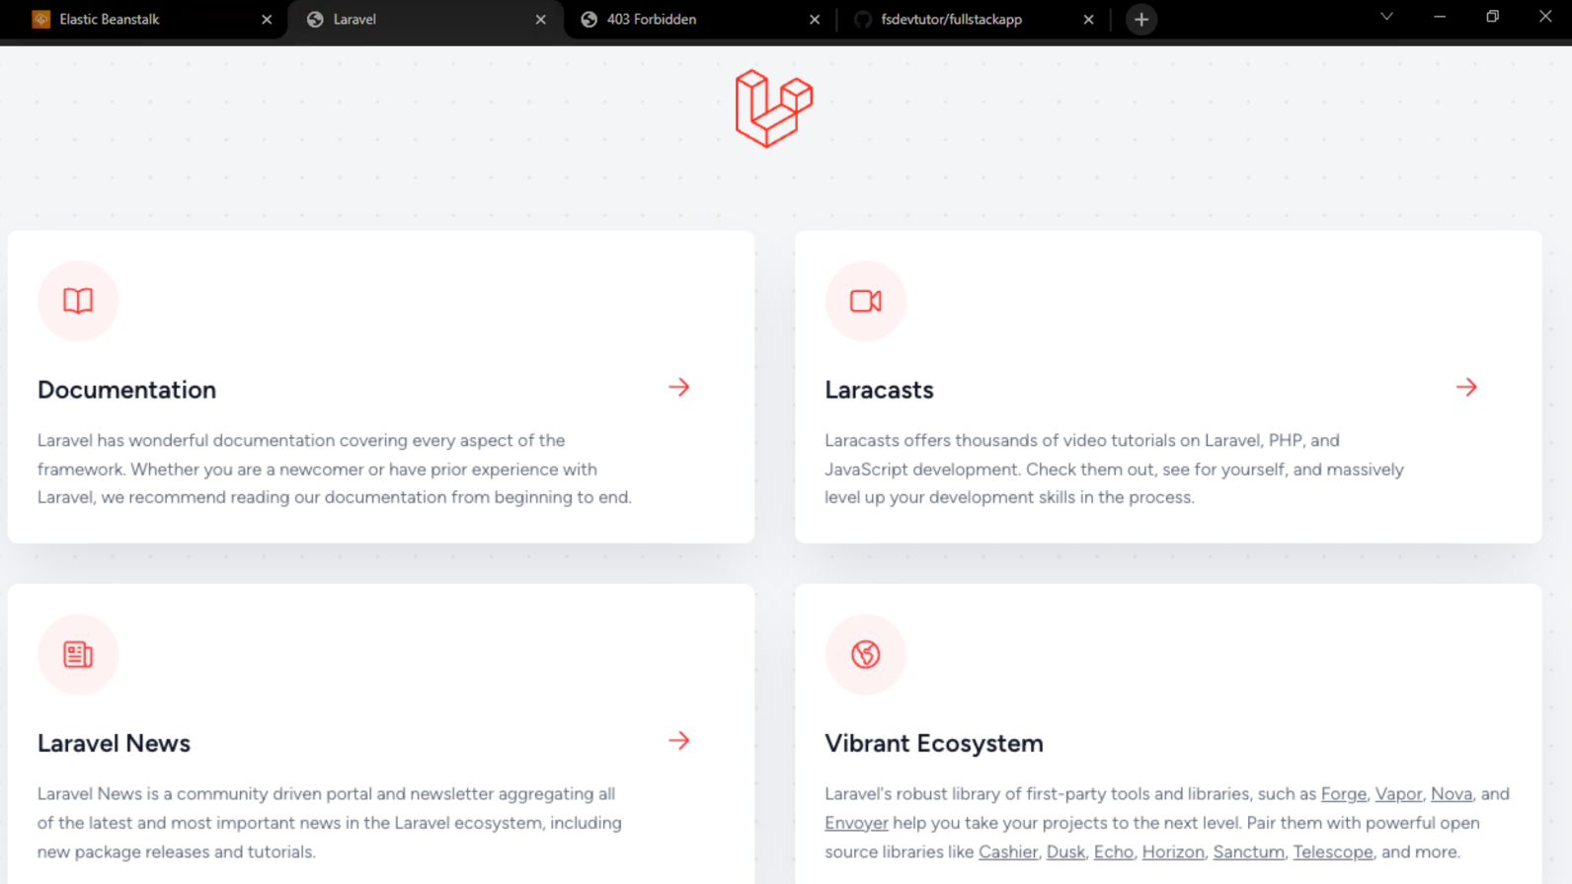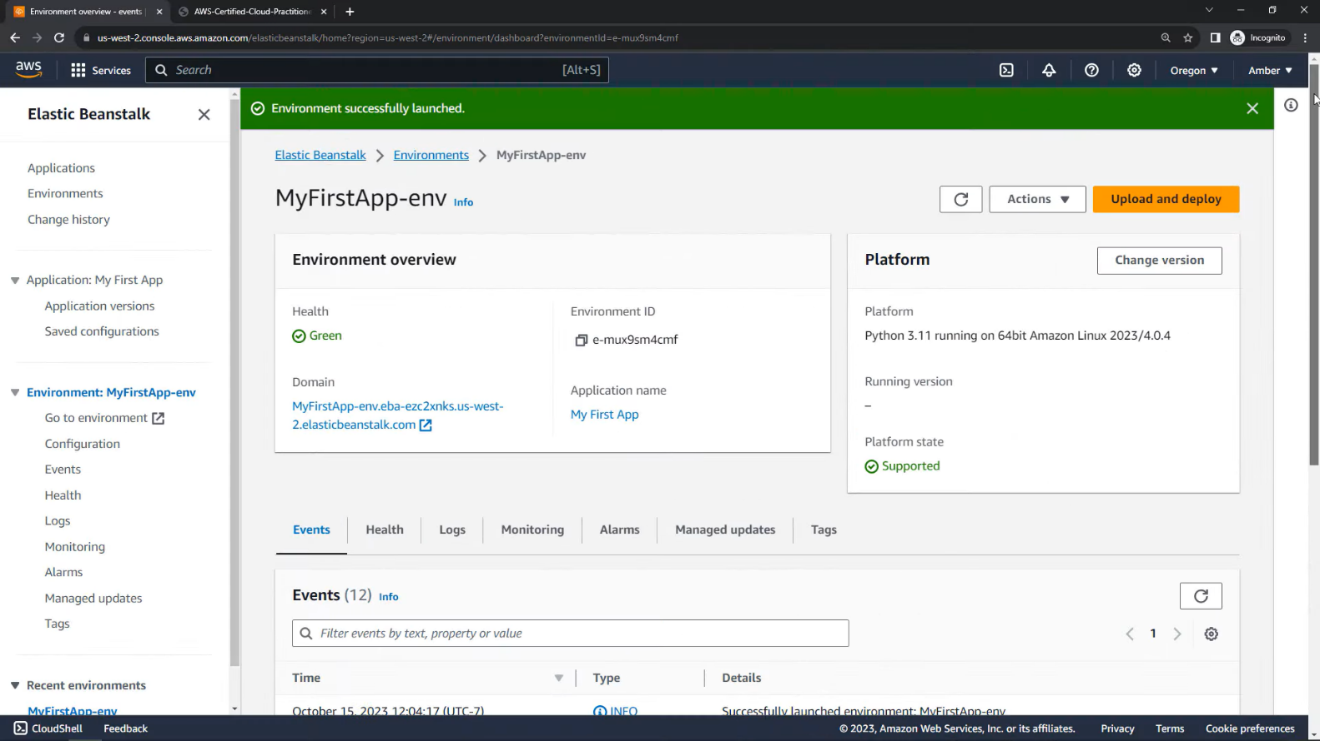

**Conclusion**

In conclusion, the exploration of leveraging Amazon Web Services (AWS) Elastic Beanstalk for hosting full-stack applications has provided valuable insights into streamlining the deployment lifecycle and enhancing development workflows. Through a comprehensive methodology encompassing setup, configuration, deployment, optimization, and documentation, developers have gained practical knowledge and skills necessary to harness the power of Elastic Beanstalk effectively.

By abstracting away infrastructure complexities and automating deployment, scaling, and monitoring tasks, Elastic Beanstalk enables developers to focus on writing code and delivering innovative solutions without the burden of managing infrastructure. The project has demonstrated how Elastic Beanstalk simplifies the deployment process for both backend and frontend components of full-stack applications, while also providing scalability, reliability, and cost efficiency.

Moreover, the project has explored advanced topics such as continuous integration and deployment (CI/CD), scalability and auto-scaling, monitoring and management, cost optimization, and security best practices. By addressing these aspects comprehensively, developers are equipped with the knowledge and tools necessary to deploy and operate full-stack applications on Elastic Beanstalk with confidence and efficiency.

Through real-world use cases, examples, and documentation, developers have gained practical insights into the practical applications and benefits of Elastic Beanstalk in various scenarios. Additionally, the project has fostered knowledge sharing and collaboration within the developer community, enabling developers to learn from each other's experiences and best practices.

As technology continues to evolve, Elastic Beanstalk remains a powerful platform for deploying, managing, and scaling full-stack applications on the AWS cloud infrastructure. By embracing Elastic Beanstalk and leveraging its capabilities effectively, developers can accelerate the deployment lifecycle, iterate rapidly, and deliver reliable, scalable applications to end-users with confidence and efficiency.

In conclusion, the project has provided a comprehensive guide for developers on leveraging Elastic Beanstalk for hosting full-stack applications effectively, empowering them to harness the full potential of AWS cloud services and drive innovation in their respective domains.